1. *Health Check API*

*Sometimes, it may happen that a particular service instance is running but is incapable of processing any request. Such services can be termed “unhealthy.”*

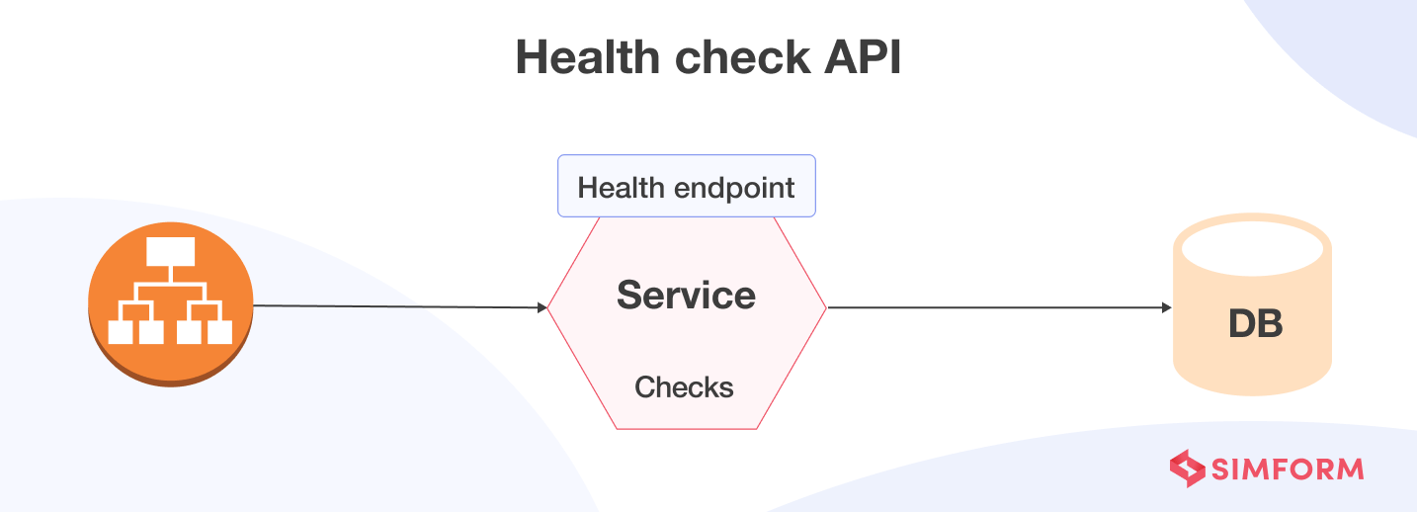

*Development teams have begun to implement health check APIs to mitigate the problems arising from unhealthy services.*

*A health check API is a REST service implemented within microservice components. It returns the operational status of a service and the service’s ability to connect with other dependent services. This way, the health check API helps developers know whether the microservices are working as desired or if troubleshooting is necessary.*

*The ideal health check API mechanism would continually find the “unheathy” services and stops rerouting traffic to those instances. If the health check of a service fails, the automated recovery process terminates or recreates the affected service. Lastly, it notifies the deployment infrastructure whether the service is ready to handle the traffic after troubleshooting. Whether it’s the* ***dependencies, system properties, database connections, endpoint connections, or resource availability****, a health check can evaluate everything a typical microservice requires. A microservice is considered available only when all the health checks configured within it are successful. If one or more checks fail, that microservice is considered unavailable.*